



**Creo Add to Teamcenter - Managed**

PLM-S

Damstraat 70 - B 9220 Hamme (VL), BE 0684.702.709

www.plm-s.com

**User Guide - V 5.0**

Table of Contents

User Interface 2

Main Menu Bar 2

Sections 2

Execution 4

Login Session 4

New Session 5

Retrieve Data 6

Assign Item Id 8

Upload to Teamcenter 9

Existing Data Upload 9

Validation 9

Warning Message Section 10

Property Update 10

Revise 11

Copy Paste 11

Refresh 11

Property Mapping 11

Column Selection 11

Action Column Bulk Update 12

Functions 13

Use cases 16

User Interface

**Main Menu Bar**

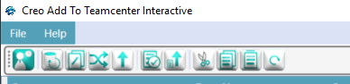

**Sections**

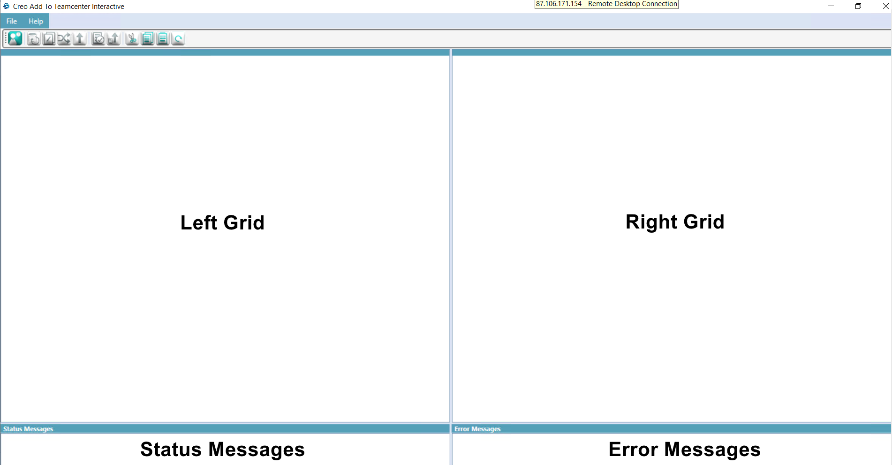

**Left Grid**

The left grid will contain Creo data with Model manager properties

**Right Grid**

The right grid will contain the Teamcenter data with properties if the object already exists in Teamcenter

**Status Message**

In this grid, we can get backend process messages.

**Error Message**

An error message will display if any issue or warning message came while uploading to Teamcenter or Validating the data.

**Buttons**

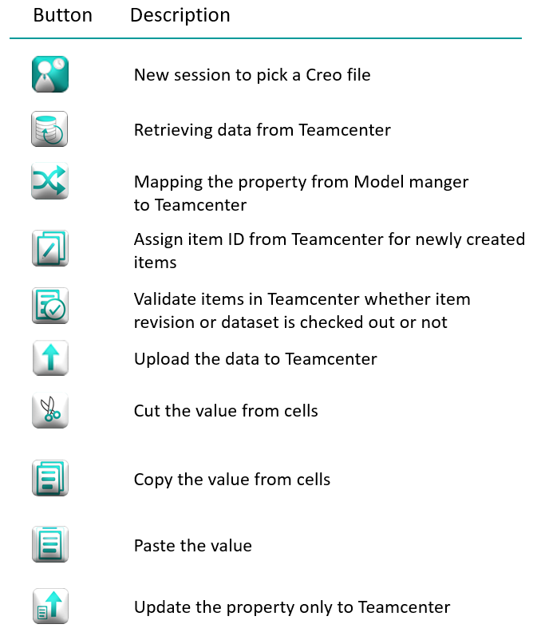



**Launch**

Double click on Creo Add to Teamcenter-Interactive.exe to launch the application.

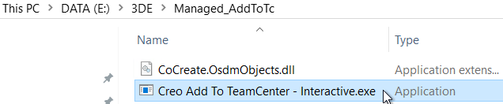

**Login Session**

Enter User ID, Password, and group (optional) and click login

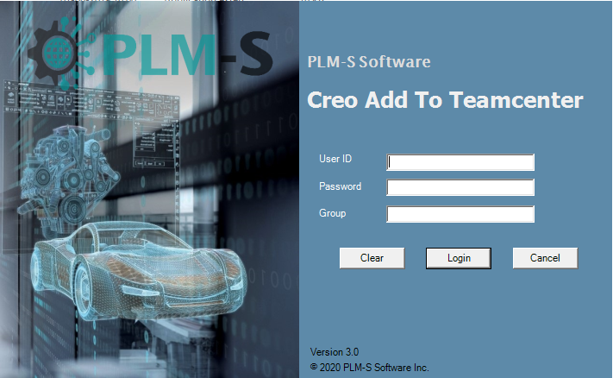

After a successful login, the Creo Add to Tc application interface will be opened

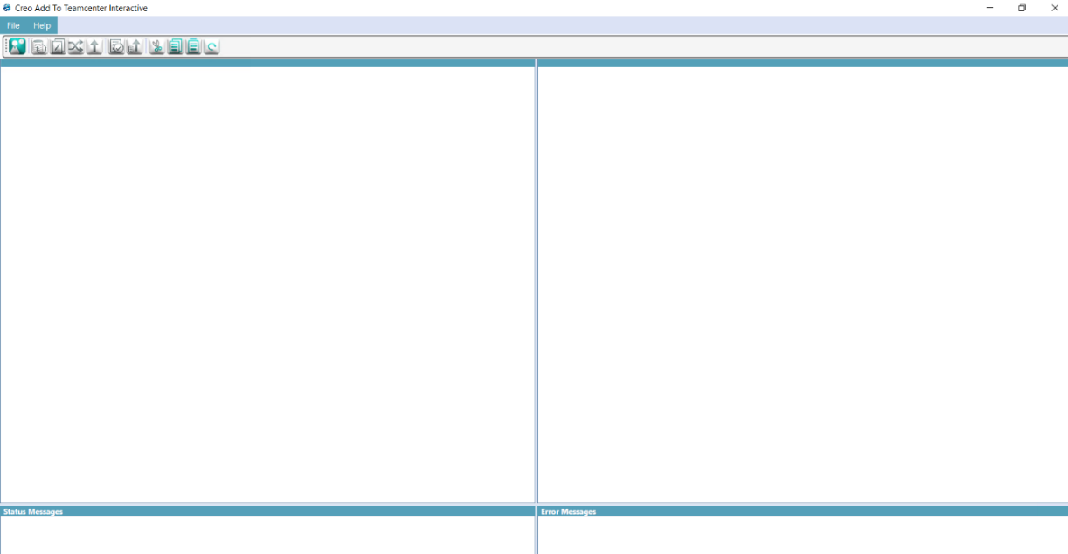

Click  New Session icon

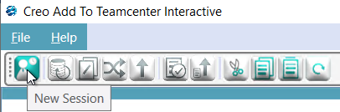

A pop-up window will appear. In the pop-up window select the .pkg file and click Open

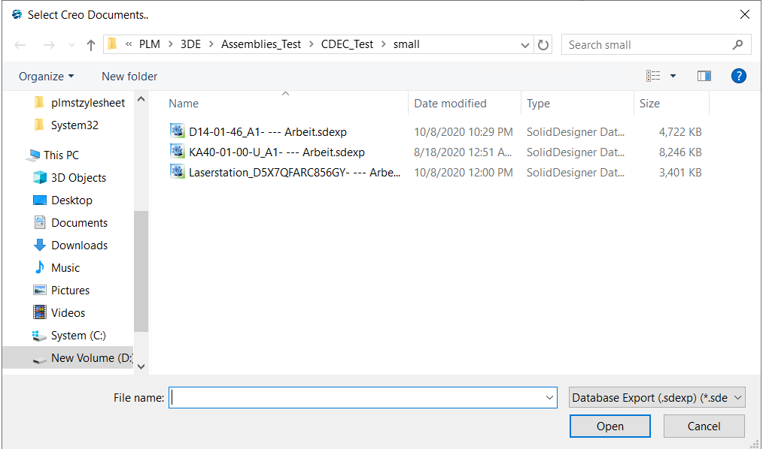

This will load the complete structure of assembly and Model Manager properties in the left grid along with its related drawing(.mi) file

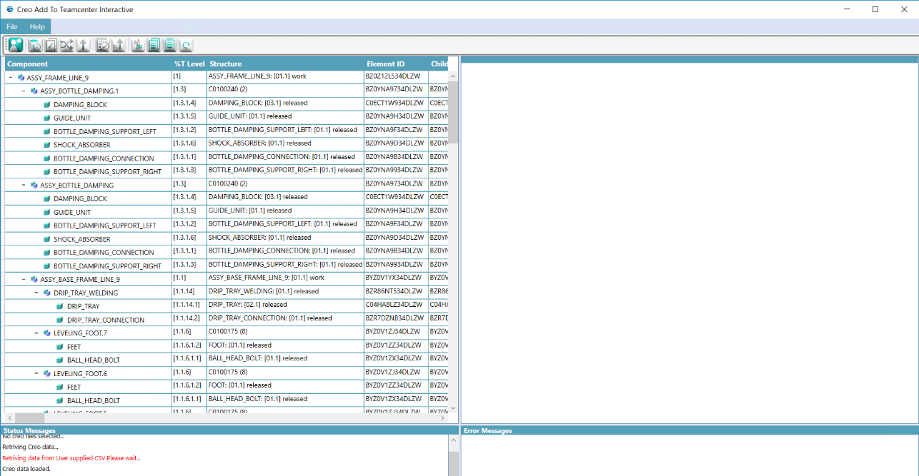

Retrieve Data icon

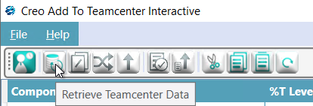

The Creo data along with the Model Manager properties will be moved from the left grid to the right grid. Since this is a fresh new assembly going to be uploaded to Teamcenter there will not be any Teamcenter data present.

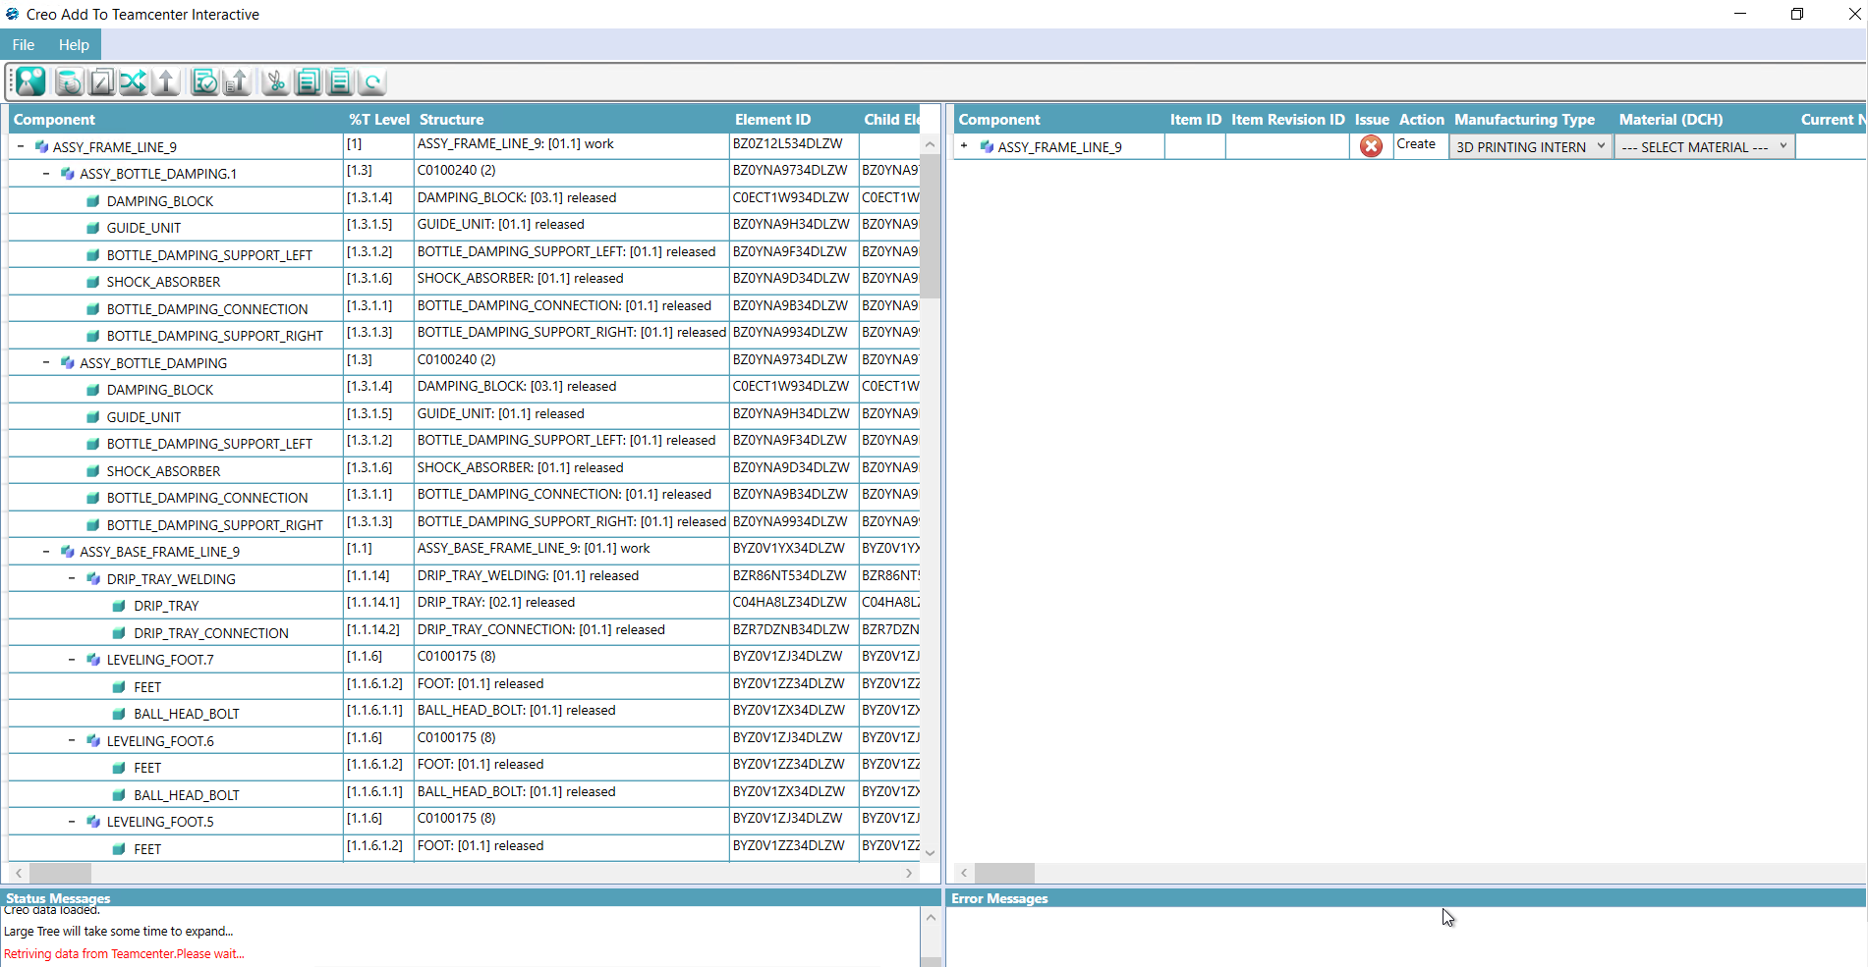

Right-click on the header column in the right grid and select Expand all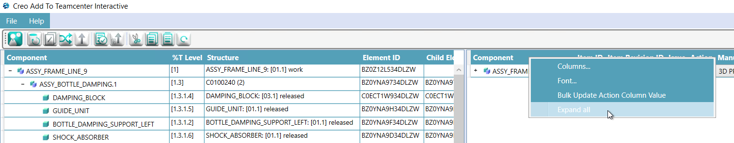

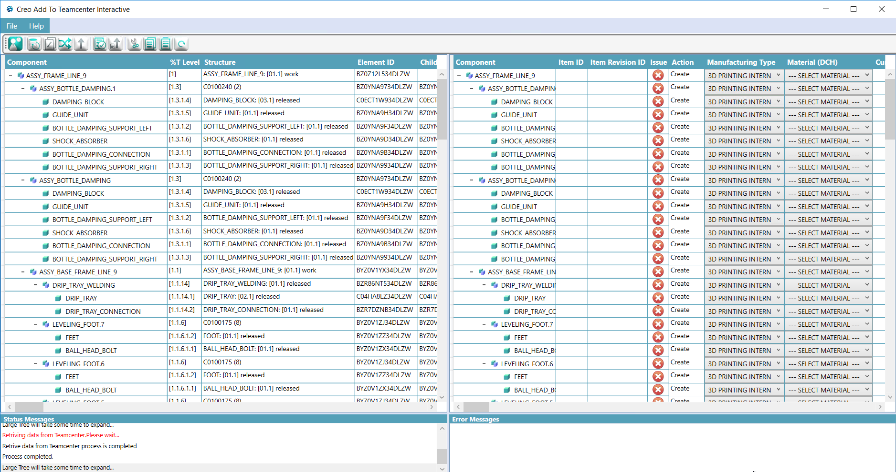Now the whole assembly structure will be expanded in the right grid

Assign Item Id icon, Item Id will be assigned in Teamcenter for all the objects in the assembly structure

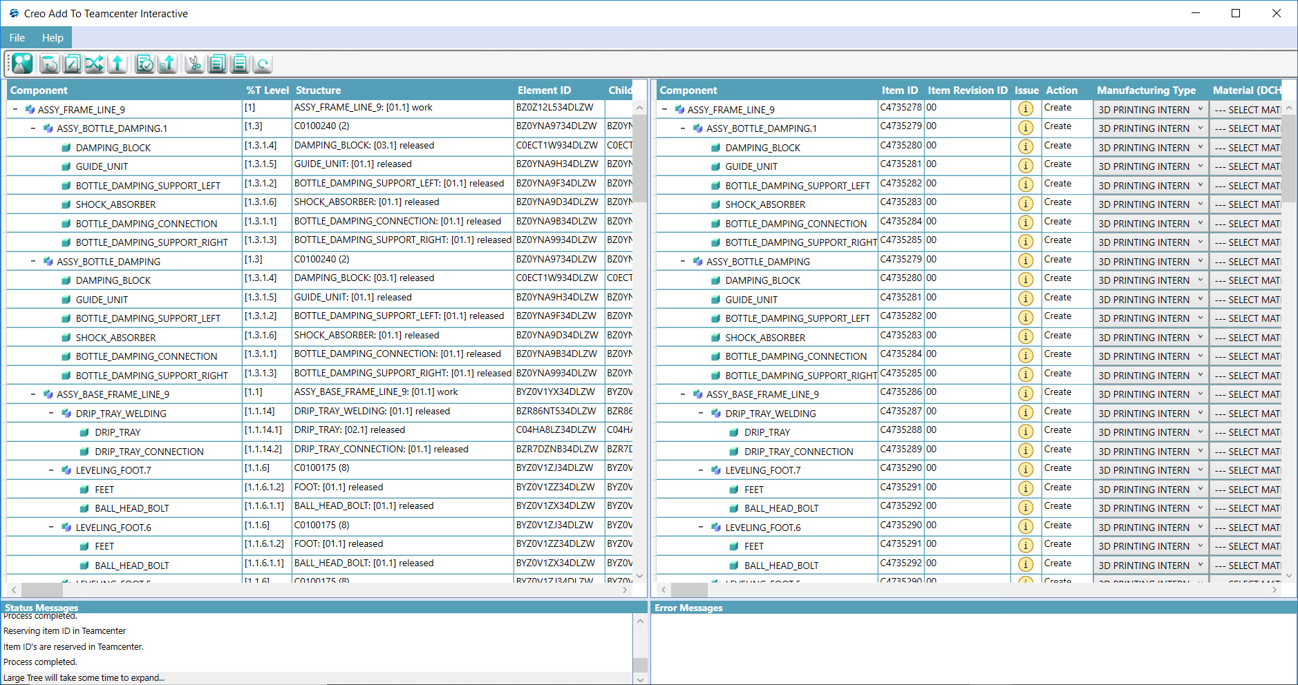

Expand all and click Upload to Teamcenter  icon to upload the data to Teamcenter

Existing Data Upload

In some cases, if some item/items in the assembly are already present in Teamcenter then the Assign Item Id icon will be greyed out or disabled state like 



During those cases click on  Run Managed Validations icon

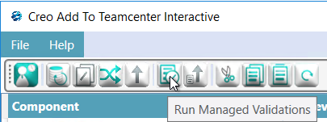

Assign Item Id icon will be enabled. Now click the Assign Item Id icon to assign item id for the new items in the assembly and do the upload process as usual.

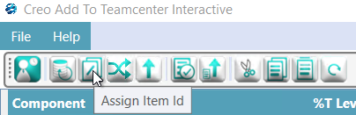

**Warning Message Section**

The issue column will show the warning messages while performing **Validate to Tc** and **Upload to Tc** action

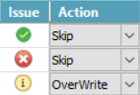

 Error – Cannot upload data to Teamcenter

 Info – Information to User, also a warning is displayed as info.

 Success – No issue to upload to Teamcenter

Click on the Error  or info  symbol to get full messages. These messages will show on the bottom right side **Warning message section.**

**Property Update**

We can update property alone by using the property update  button instead of updating the whole assembly. If we modified any cells in the grid, the corresponding action column will change automatically to **Overwrite.**

**Revise**

We can revise an item by changing the **Action** column to revise.

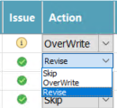

**Copy Paste**

We can copy and paste the values between the property cells by using the copy  and paste  button.

**Refresh**

Click the refresh  button to refresh the Teamcenter data in the right grid

**Property Mapping**

button to map Model manager property to Teamcenter property. Usually, it will map left grid properties to corresponding right grid objects.

**Column Selection**

Right-click on the right grid column to bring up the settings dialogue.

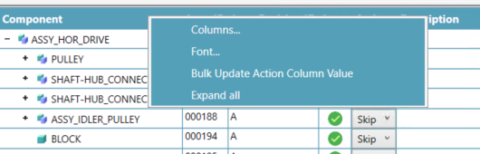

Click **Columns…** option to show/hide the columns in the right grid

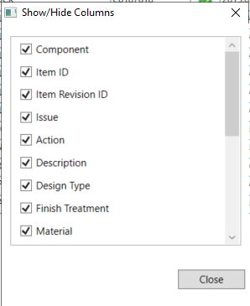

**Action Column Bulk Update**

Click the **Bulk Update Action Column Value** option to change all values in Action Column.

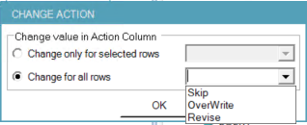

**Functions**

|  |  |
| --- | --- |
|  | Open Creo File in Session.  Supported Creo file extension types sda, sdexp, pkg, bundle  If Creo loads the complete structure of the assembly in the left grid  The related drawing (mi) file for the Creo model is loaded and automatically and ready to be uploaded to Teamcenter  When the link to the model manager is configured in the client, the properties from the model manager are loaded in the left grid as well |
|  | Retrieve data from Teamcenter  Data is moved from the left grid to the right grid. The data is validated in Teamcenter and the appropriate action is set in the “Action” column. The properties of Teamcenter are displayed in configurable columns.  Content id in the Creo file is the key which is stored in Teamcenter to identify and overwrite the data in Teamcenter  If there is an issue in uploading the data to Teamcenter, it is represented by icons in the “Issue” Column. When the icon is clicked, the appropriate error message is shown in the error message section.  Representation in the Issue Column  Error – Cannot upload data to Teamcenter  Info – Information to User, also a warning is displayed as info.  Success – No issue to upload to Teamcenter |
|  | Assign Teamcenter Data  Assigns the Teamcenter data such as the item id, revision id, and all the mandatory properties to all the required objects in the right grid. |
|  | Upload to Teamcenter  When the data in the right grid has no errors, it is possible to upload the data to Teamcenter. The status could be tracked in the status messages section.  After the upload, the right grid is refreshed and the data is loaded back from Teamcenter into the grid, thereby gives information to the user on what has been uploaded to Teamcenter. |
|  | Run Validations  Run the Teamcenter validation for the data and refreshes the “Issue” column |
|  | Cut  Cut Operation of a single value or also values from complete column cut is possible |
|  | Copy  Copy Operation of a single value or also values from the complete column copy is possible |
|  | Paste  From the clipboard, paste the single value or also values on to the complete column |
|  | Refresh Teamcenter Information  Connects to Teamcenter, updates the information in the grid with the data from Teamcenter |

**Use cases**

The Creo Add to Teamcenter application can be used to either migrate the Creo data from Model Manger to Teamcenter and manage the Creo data using the Creo live integration in Teamcenter (or) share the Creo data to Teamcenter in which the JT will be generated via Dispatcher in Teamcenter and use the Model manager to still manage the Creo data.

step-up: Migration of Creo from model manager to Teamcenter

Use the Creo Add to Teamcenter to read the Creo data and its properties from Model Manager

Enhance the data in Creo Add to Teamcenter, define mappings from Model Manager to Teamcenter Uploads the Creo data as datasets to Teamcenter.

The item revision which holds the Creo datasets is customizable through the Teamcenter Preferences.

Works on Demand. Only when the data is needed in Teamcenter, the application shall be used

Any future changes in Creo will be done only in Teamcenter

Completely driven by the user. On request, the Creo Add to Teamcenter could be provided as a command-line tool to run in batch mode.

stay as it is: Use Model Manager as a master for creo, share data to Teamcenter

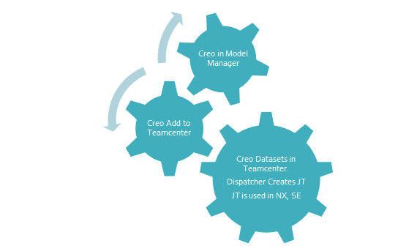

Continue to use Model Manager to master the Creo Model changes

Use the Creo Add to Teamcenter tool to synchronize the Creo data (only Upload) to Teamcenter.

The Creo Add to Teamcenter tool is smart to identify the existing Creo model in Teamcenter and do the updates in Teamcenter.

The upload automatically triggers a dispatcher request to create/update the JT file.

The JT file is used as a component in NX or SE. This approach satisfies the Multi-Cad requirement but requires the maintenance of two systems.